Chicken Bruschetta

* [Nutrition](http://www.teambeachbody.com/teambeachbodyblog/category/nutrition)

* [Recipes](http://www.teambeachbody.com/teambeachbodyblog/category/nutrition/recipes)

April 8, 2015

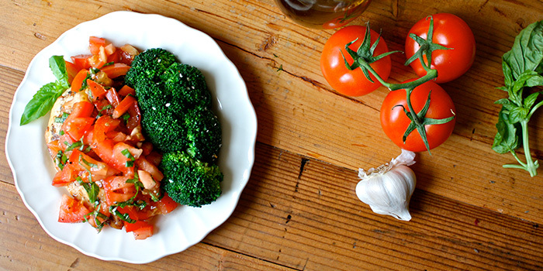

Tomato, basil, and balsamic vinegar makes a delicious topping for this Italian-style chicken bruschetta dinner.

**Total Time:** 20 min.  
**Prep Time:** 10 min.  
**Cooking Time:** 10 min.  
**Yield:** 1 serving

**Ingredients:**  
1 medium tomato, chopped  
2 Tbsp. thinly sliced fresh basil  
1 clove garlic, finely chopped  
½ tsp. extra-virgin olive oil  
1 tsp. balsamic vinegar  
1 tsp. onion powder  
Sea salt and ground black pepper (to taste; optional)  
5 oz. raw chicken breast, boneless, skinless

**Preparation:**  
1. Combine tomato, basil, garlic, oil, vinegar, onion powder, salt, and pepper in a medium bowl; mix well. Set aside.  
2. Preheat grill or broiler on high.  
3. Grill or broil for about 4 to 5 minutes on each side, or until no longer pink in the middle and juices run clear.  
4. Top chicken with tomato mixture.

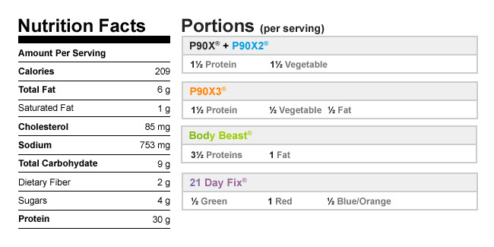

Authors

[Beachbody](http://www.teambeachbody.com/teambeachbodyblog/author/beachbody)

Tags[chicken](http://www.teambeachbody.com/teambeachbodyblog/tag/chicken), [dinners](http://www.teambeachbody.com/teambeachbodyblog/tag/dinners), [high-protein recipes](http://www.teambeachbody.com/teambeachbodyblog/tag/high-protein-recipes), [lunches](http://www.teambeachbody.com/teambeachbodyblog/tag/lunches),[recipes](http://www.teambeachbody.com/teambeachbodyblog/tag/recipe)

RELATED POSTS